Deciding on your plan for after school can be an exciting and challenging task- there are so many options to research and decisions to make:
College or 6 Form? Diplomas or A-Levels?
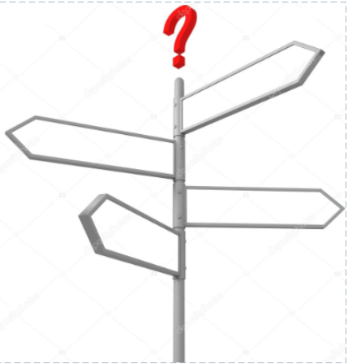
Apprenticeships? T-Levels?
University in the future…? Career?

It can help if you know yourself- your likes and dislikes, your skills, and interests- before working out how these could match with possible career paths…

Think about:
- How do you spend your time- Do you have a hobby that you enjoy?
- What are you good at?
- What do you find interesting?

STEP 1: Write down as many of your skills and interests that you can think of:
What do you like to do in your spare time? | Favourite subjects at school? | Other things you can do?
Click or tap here to enter text. | Click or tap here to enter text. | Click or tap here to enter text.

Now think about your personality and characteristics:
- Are you outgoing?
- Do you like to think things through carefully?
- How would your friends describe you?

This can help you decide what type of career suits your personality, for example:
if you are an active and practical person you may want to find out more about careers in the fitness industry or construction?
if you are caring you could explore careers in health and social care?

STEP 2: Tick all that apply:
☐ able to adapt  ☐ able to prioritise  ☐ active  ☐ approachable  ☐ attention to detail  ☐ budgeting  ☐ calm  ☐ caring  ☐ communicate clearly  ☐ confident  ☐ cope with pressure  ☐ creative  ☐ curious  ☐ decision-making  ☐ determined  ☐ design skills | ☐ enthusiastic  ☐ fast learner  ☐ flexible  ☐ friendly  ☐ focussed  ☐ good listener  ☐ hard working  ☐ honest  ☐ innovative  ☐ initiative  ☐ IT skills  ☐ leadership skills  ☐ logical  ☐ methodical  ☐ negotiation  ☐ observant | ☐ patient  ☐ persistent  ☐ planning-skills  ☐ polite  ☐ persistent  ☐ positive attitude  ☐ practical  ☐ presenting skills  ☐ problem-solving  ☐ punctual  ☐ research skills  ☐ resilient  ☐ teamwork  ☐ time management  ☐ trustworthy  ☐ well organised
- If you are getting stuck- ask a friend or family member who knows you well to help
Skills are gained through experience
It’s a good idea to try new things and get involved in a range of activities- what can you do?
- extra-curricular activities and school clubs?
- sports and fitness?
- volunteering?
- work experience?

STEP 4: Identify your top 10 skills
- List them with an example of how you use them through the things you do at home, at school, work experience or volunteering:
Skill/attribute | Example of how I can evidence this
Organised | I use my school planner to record all my homework and make sure I hand it in on time.
Click or tap here to enter text. | Click or tap here to enter text.
Click or tap here to enter text. | Click or tap here to enter text.
Click or tap here to enter text. | Click or tap here to enter text.
Click or tap here to enter text. | Click or tap here to enter text.
Click or tap here to enter text. | Click or tap here to enter text.
Click or tap here to enter text. | Click or tap here to enter text.
Click or tap here to enter text. | Click or tap here to enter text.
Click or tap here to enter text. | Click or tap here to enter text.
Click or tap here to enter text. | Click or tap here to enter text.
Click or tap here to enter text. | Click or tap here to enter text.

Hopefully you are now starting to understand yourself, your skills and attributes a little more…
…You can also use this list to create a CV and apply for jobs and apprenticeships in future

