Roles in Construction

Activity Sheet
Design Management
Name: Miles Rooker, Senior Design Manager
What do you do? I manage all the processes in producing a set of design documents that a building can be built from. I encourage and inspire design consultants whilst making sure current legislation, standards and codes of practice are followed. I ensure design information is of the right quality and keeps pace with project timescales whilst eliminating health and safety risks in the design and financial risks during construction.

The challenge
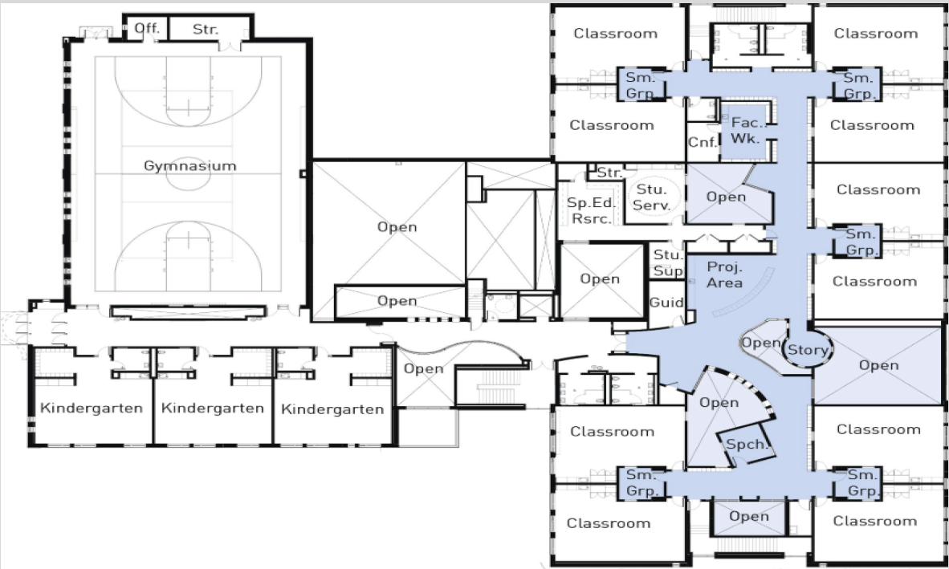
You are a design manager on a construction project, the client would like you to design a layout to include classrooms for reception to Year 6. Facilities also include a nursery on site.

Consider positions for each classroom, a canteen, sports hall and toilets, as well as corridors between them.
You may want to include the below as well:

• Play areas
• Grass playing field
• Carpark for 20 cars
• Loading area for kitchen deliveries.

We are a safe pair of hands with a difference.

We blend sound delivery methods with a fast-paced, ideas-driven culture that pushes us to constantly improve.

